BUILDING A PYRAMID

“A ramp to the sky is built for him, that he may go up to the sky on it….He flies as a bird and he settles as a beetle on an empty seat that is in the ship of Re.”

Some of the pyramids were decorated inside with spells carved on the walls. These are known as the ‘Pyramid Texts’. They were magical spells like the one above which were repeated with the idea that magic could move the king’s body into the sky. The ‘ramp’ mentioned in the spell probably referred to the pyramid itself. Most pyramids have been explored by archaeologists but apart from the large stone coffin (sarcophagus) in which the body was buried, few remains have been found either of the bodies or of the treasures which were buried with the kings. In many cases, the pyramid was probably robbed soon after the king’s burial. One of the reasons why the Egyptians stopped building pyramids was because they could be so easily seen and plundered. It is possible, however, that undiscovered chambers remain in some of the pyramids and that archaeologists may yet make new finds.
In the last century the famous British Egyptologist, Sir W. Flinders Petrie, discovered wonderful jewellery belonging to royal princesses in tombs near the pyramid of King Sesostris II at Lahun. Some queens seem to have had separate tombs but the small pyramids which we see at Giza may also have been used for them, unless these housed the king’s own internal organs which were removed at the time of mummification. Since no human remains have been found there, their use remains uncertain.

Step Pyramid Bent Pyramid True Pyramid
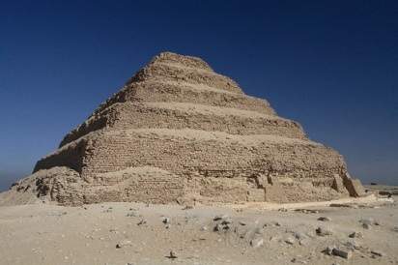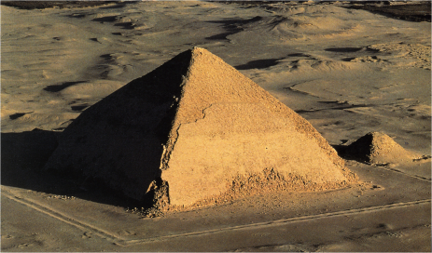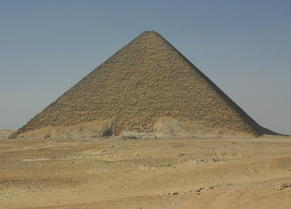
www.traveltamed.com www.skyscrapercity.com www.richard-seaman.com

The pictures above show the development of the pyramid. The first pyramid built at Saqqara close to the capital city of Memphis had steps. It was the burial place of King Zoser. The man, who built the pyramid, Imhotep, may have intended to build a series of tombs one on top of another. Each step looks like the outline of the early tombs which Egyptologists call ‘mastabas’ (which means bench shaped in Arabic). The Egyptians moved from building step pyramids to true pyramids going through various stages in between. One of these was the ‘bent’ pyramid where changes were made to the angles of the sides. The location of the burial area might be inside or below ground.

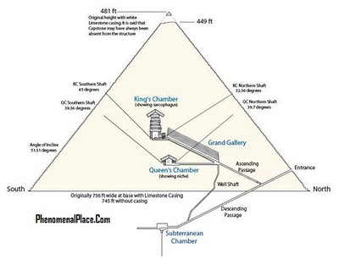

BUILDING A PYRAMID: WORKSHEET

- Look at the handout and name the three types of pyramid the Egyptians built.
a.__________________ b.____________________ c. ___________________
- The wall decorations in the pyramids were called the________________ __________________
- What were these decorations supposed to do? __________________________________________
__________________________________________________________________________________________________________________________________________________________________
- Name the large stone coffin found in pyramids. __________________________________________
- Why were the pyramids robbed? ______________________________________________________
__________________________________________________________________________________________________________________________________________________________________

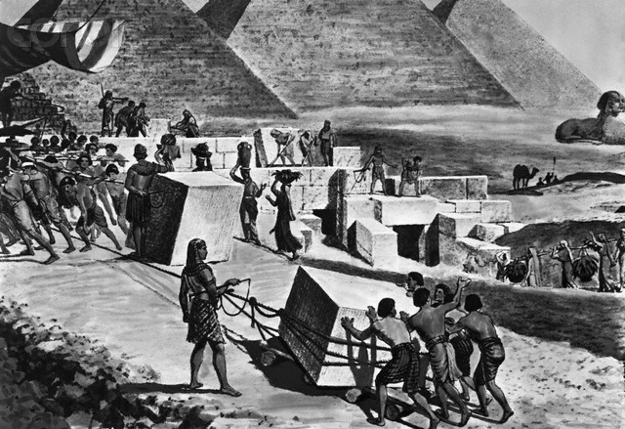 www.affordablehousinginstitute.org
Using the picture above, fill in the missing words.
The picture shows a __________ where stone blocks are being prepared to ___________ a ______________. The ______________ are doing several _______. They include the cutting, wedging, _________ an d ____________ a stone block into position on __________ supports. After this the stone block will be moved.
wooden quarry workers pyramid jobs build pulling levering

HOW WAS THE STONE TRANSPORTED FROM THE QUARRY TO THE BUILDING SITE?

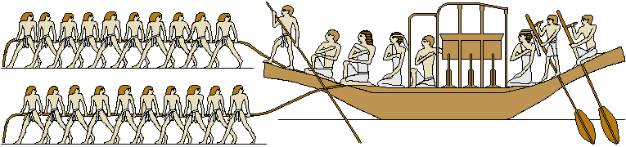
Large wooden sailing boats transported the stone along the Nile River. Slaves rowed the boat with the help of a single sail. Several of these boats worked up and down the Nile.

HOW THE PYRAMIDS WERE BUILT:
Method One:

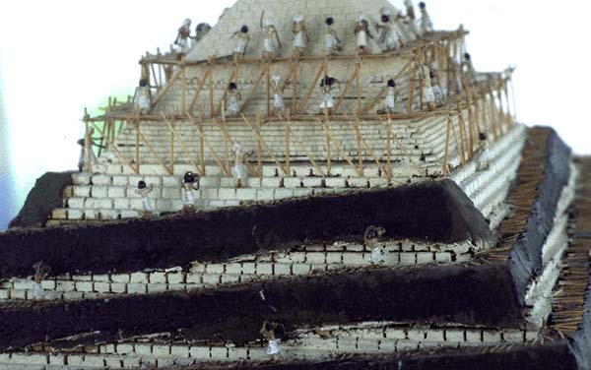 www.spardharthi.blogspot.com
Look carefully at the picture above and describe how the pyramid was constructed. ________________________________________________________________________________________________________________________________________________________________________________________________________________________________________________________________________________________________________________________________________________________________________________________________________________________________________________________________________________________________________________________________________________________________________________________________________________________________________________________________________________________________________________
Method Two:
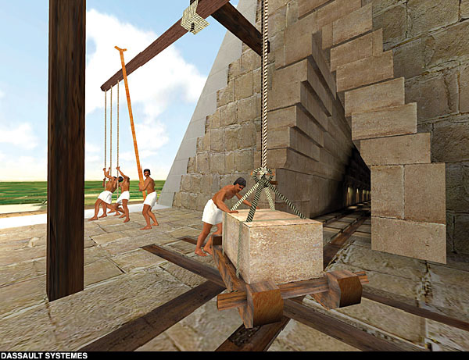 www.patentpending.blogs.com
Read the passage below and fill in the missing words:
The pyramid was built in _________. After laying the stones for the ________ they raised the remaining stones to their places by means of machines formed of short wooden ___________. The first machine raised them from the ground to the ______ of the first step. On this step there was another machine which received a stone upon its arrival and conveyed _______ to the second _________, whence __________ machine advanced it still higher. Either they had as many machines as there were steps in the pyramid or possibly they had but a single machine which, being easily moved, was transferred from tier to ________ as the stone rose – both accounts are given. The _________ portion of the pyramid was finished first, __________ the middle and finally the part which was lower and nearest the ground.

